**Networking behind Bluetooth Tethering**

Tethering means enabling another device to use the host's internet connection. Bluetooth tethering is included as as in-built feature of Android since Android 4.0 Ice Cream Sandwich. Bluetooth has a profile to share internet connection called ‘Personal Area Network’ profile. We are going to see how networking communication happens behind bluetooth tethering.

We will focus on a scenario in which a laptop is connected to the internet via ethernet cable or wifi. Laptop is sharing its internet over bluetooth to mobile. **So how internet packets are routed and forwarded between laptop and mobile?**  Following networking concepts explain the scenario:

**Network bridge :** Bridge is used to pass traffic between the two interfaces. If a laptop is connected to ethernet to access internet, then one of the interface added to bridge is eth0 (ethernet). For bluetooth tethering, on connection to mobile, pan profile creates and add one more interface to bridge called bnep0.

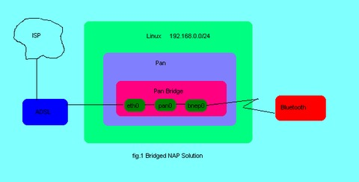

**dnsmasq :** The idea of a DHCP server is to dynamically distribute network configuration parameters, such as IP addresses, for interfaces and services. Dansmasq server provides IP address to bridge. When mobile connects to bluetooth pan profile created by laptop, it requests for IP to dnsmasq server. Dnsmasq server assigns IP to mobile.

**IP Masquerading :** IP masquerading is a process where one computer acts as an IP gateway for a network. All computers on the network send their IP packets through the gateway, which replaces the source IP address with its own address and then forwards it to the internet. Perhaps the source IP port number is also replaced with another port number, although that is less interesting. All hosts on the internet see the packet as originating from the gateway.

Any host on the Internet which wishes to send a packet back, ie in reply, must necessarily address that packet to the gateway. Remember that the gateway is the only host seen on the internet. The gateway rewrites the destination address, replacing its own address with the IP address of the machine which is being masqueraded, and forwards that packet on to the local network for delivery.

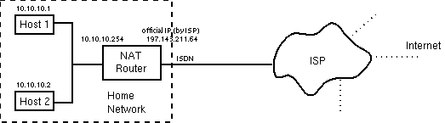

**IP forwarding :** IP forwarding also known as IP routing or Internet routing is a process used to determine which path a packet or datagram can be sent.The process uses routing information to make decisions and is designed to send a packet over multiple networks.

Generally, networks are separated from each other by routers.For packets to travel between networks, they must be “routed” from one network to another. These routers contain a routing table that can contain specific instructions on how to send packets to a destination network (known as a route), or a set of generic instructions on where to send packets that do not match any of the other specified routes (called a default route), or both.